Claude glass believed to be John Dee's scrying mirror, Europe, undated
MADE:

Unknown in Europe
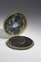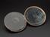
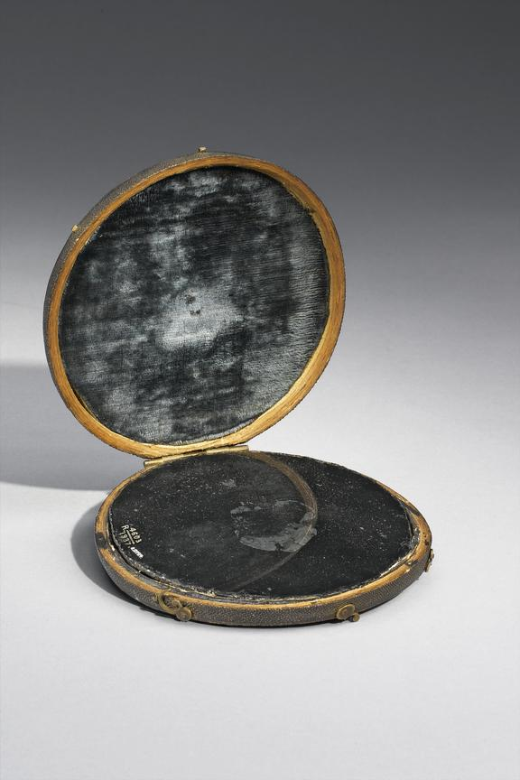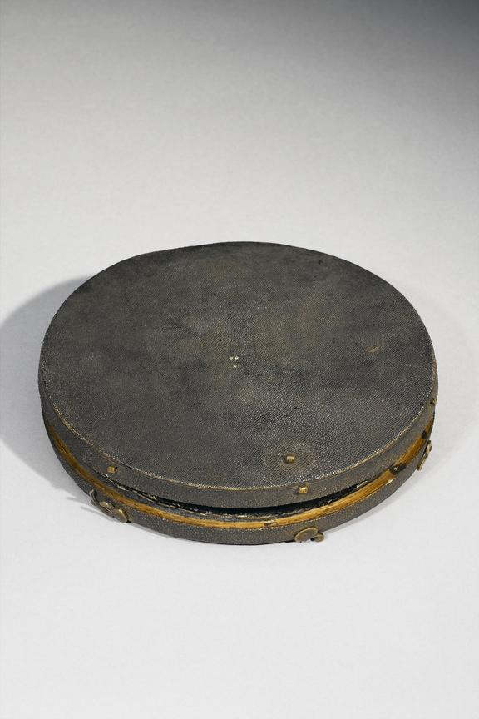Errore. Il nome file non è specificato.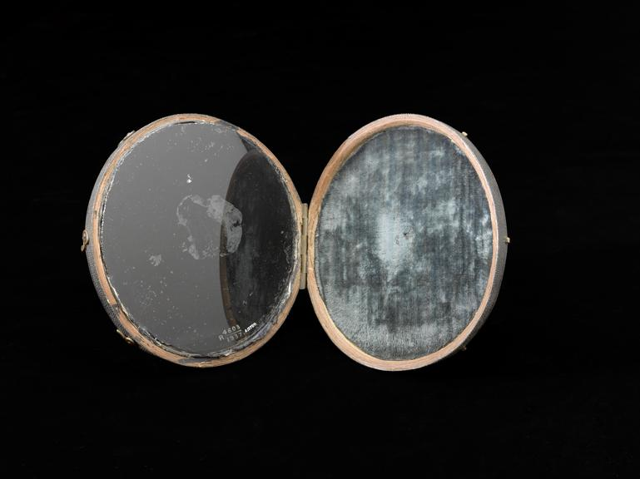
Use this image
Science Museum Group Collection
© The Board of Trustees of the Science Museum
Claude Lorrain mirror in shark skin case, believed at one time to be John Dee's scrying mirror
Stored in a sharkskin case and thought to have once belonged to John Dee (1527-1609), an English mathematician and astrologer, this object is known as a Claude glass. Associated with Claude Lorrain (1600-82), a French landscape painter, the base is made from a convex piece of glass with a black blacking. They were normally used by artists to look at landscapes. Dee is said to have used this object to predict the future by looking into the glass as if it were a crystal ball. This practice is known as scrying, a form of divination. Divination is the attempt to predict the future from signs and symbols and has been used for thousands of years in an effort to forecast the course of an illness or find the best treatment.

RELATED PEOPLE
- John Dee

Etymology[edit]
Named after French painter Claude Lorrain (c. 1600–1682).

Noun[edit]
Claude glass (plural Claude glasses)
- A slightly convex mirror, commonly of black glass, once used by artists to view landscapes and produce works similar to those of Claude Lorrain. synonyms ▲
Synonyms: Claude Lorraine glass, black mirror

Further reading[edit]
- Claude glass on Wikipedia.
- he object pictured above is a Claude glass, a key accessory for any circa-1700s British tourist. Here’s how it works: when you arrive at a scenic spot, you turn your back to the view, and hold up the mirror to look at the scenery reflected in the glass. On the face of it, it’s a somewhat absurd concept. Imagine tourists flocking to a famous beauty spot, only to turn around and fix their eyes on its reflection in a tiny dark mirror.
- Unsurprisingly, the practice sometimes resulted in accidents. The poet Thomas Gray recorded that, when backing up to get a better view of the scenery in his Claude glass, he “fell down on my back across a dirty lane with my glass open in one hand, but broke only my knuckles.”
- The Claude glass was named for Claude Lorrain, a French landscape painter beloved for his sunset-tinted depictions of Roman ruins. Carrying a Claude glass was like having a portable Lorrain in your pocket, ready to transform any jumble of trees and rocks into a vision of painterly charm: framed and set apart from the rest of the landscape, color palette simplified, bathed in gentle, hazy light.
- Something dramatic had happened to the way people saw the land itself.
- With the help of the glass, amateur painters could imitate Lorrain with ease. The more ambitious carried glass slides in different colors, which they could use to superimpose tones on the landscape. With the help of the slide, the land could be suffused with autumnal gold or draped in blue frost; the light of day could be transformed into dawn, sunset, or moonlight.
- The popularity of the Claude glass was accompanied by a sea-change in how the British thought about landscapes. Consider the case of the English Lake District. In the 1600s, it was widely regarded as an ugly and depressing spot. As one traveller put it, it was “nothing but hideous, hanging Hills” and “a confused mixture of Rocks, and Boggs.” By the late 1700s, it was one of England’s most popular tourist destinations. Something dramatic had happened to the way people saw the land itself.
This transformation was driven by a new development in aesthetic theory: the rise of “the picturesque,” which joined the sublime and the beautiful as a guiding aesthetic ideal.

