BRANDS

Brand (Wikipedia)
A brand is a name, term, design, symbol or any other feature that distinguishes one seller's good or service from those of other sellers.^{[2][3][4][5]} Brands are used in business, marketing, and advertising for recognition and, importantly, to create and store value as brand equity for the object identified, to the benefit of the brand's customers, its owners and shareholders.^{[6]} Brand names are sometimes distinguished from generic or store brands.
The practice of branding - in the original literal sense of marking by burning - is thought to have begun with the ancient Egyptians, who are known to have engaged in livestock branding as early as 2,700 BCE.^{[7][need quotation to verify]} Branding was used to differentiate one person's cattle from another's by means of a distinctive symbol burned into the animal's skin with a hot branding iron. If a person stole any of the cattle, anyone else who saw the symbol could deduce the actual owner. The term has been extended to mean a strategic personality for a product or company, so that "brand" now suggests the values and promises that a consumer may perceive and buy into. It includes the voice and the tonality of the business. Over time, the practice of branding objects extended to a broader range of packaging and goods offered for sale including oil, wine, cosmetics, and fish sauce and, in the 21st century, extends even further into services (such as legal, financial and medical), political parties and people (e.g. Lady Gaga and Katy Perry). Branding in terms of painting a cow with symbols or colors at flea markets was considered to be one of the oldest forms of the practice.
In the modern era, the concept of branding has expanded to include deployment by a manager of the marketing and communication techniques and tools that help to distinguish a company or products from competitors, aiming to create a lasting impression in the minds of customers. The key components that form a brand's toolbox include a brand's identity, personality, product design, brand communication (such as by logos and trademarks), brand awareness, brand loyalty, and various branding (brand management) strategies.^{[8]} Many companies believe that there is often little to differentiate between several types of products in the 21st century, hence branding is among a few remaining forms of product differentiation.^{[9]}
Brand equity is the measurable totality of a brand's worth and is validated by observing the effectiveness of these branding components.^{[10]} As markets become increasingly dynamic and fluctuating, brand equity is built by the deployment of marketing techniques to increase customer satisfaction and customer loyalty, with side effects like reduced price sensitivity.^{[8]} A brand is, in essence, a promise to its customers of what they can expect from products and may include emotional as well as functional benefits.^{[8]} When a customer is familiar with a brand or favors it incomparably to its competitors, a corporation has reached a high level of brand equity.^{[10]} Special accounting standards have been devised to assess brand equity. In accounting, a brand, defined as an intangible asset, is often the most valuable asset on a corporation's balance sheet. Brand owners manage their brands carefully to create shareholder value. Brand valuation is a management technique that ascribes a monetary value to a brand, and allows marketing investment to be managed (e.g.: prioritized across a portfolio of brands) to maximize shareholder value. Although only acquired brands appear on a company's balance sheet, the notion of putting a value on a brand forces marketing leaders to be focused on long term stewardship of the brand and managing for value.
The word "brand" is often used as a metonym referring to the company that is strongly identified with a brand.^{[11]} Marque or make are often used to denote a brand of motor vehicle, which may be distinguished from a car model. A concept brand is a brand that is associated with an abstract concept, like breast-cancer awareness or environmentalism, rather than a specific product, service, or business. A commodity brand is a brand associated with a commodity.

BRANDALISM

Mike Sherman, Brandalism: Building brands by vandalising the status quo, 2015, Tracey McDonald Publishers
In BRANDALISM, the follow-up to his bestselling, award-winning debut book The Best Dick, Mike Sharman delves into the (start)ups and downs associated with brand building and the need for business to dismantle, and vandalise its perceived, public-facing, persona.
Mike Sharman, the co-founder of the creative, digital agency Retroviral that has made more brands ‘go viral’, globally, than any other agency in Africa, uses his unique storytelling proposition to provide insight into 12 years of building a business from scratch, while elevating his clients to emotional, (commercial) cult status.

Brandalism - A Story Of Cultural Subversion

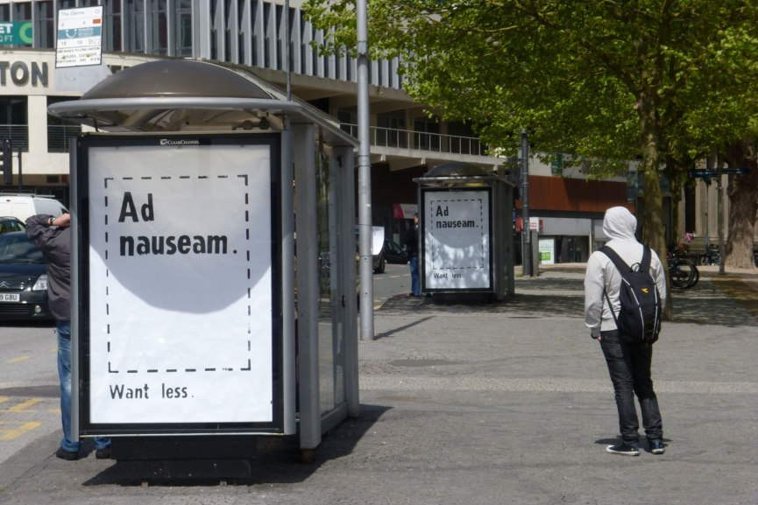artwork by Dr.D (Bristol)

What Does Brandalism Mean?
This is the issue with –isms: these notions tend to generalize a set of ideas into a body of meaning. Of course, this is an oversimplification, but the “problems” occur when there is no consensus over the mentioned set of ideas. Thus, “brandalism”, just as any other -ism for that matter, has come to be a notion potent with different meanings. It can refer to the body of cultural industries in the broadest sense, such are numerous forms of this “practice” within design or fashion industries. However, this is not going to be a story of various dispersed ideologies or different interpretations, but a specific one concerning a project which is transforming into a movement. This story began in 2012, when the project reclaimed 36 billboards in 5 cities with the help of 28 artists from 8 countries, over the course of 5 days. Two years later, in May 2014, the Brandalism project affected 360 advertising spaces by inserting original artworks, covering the advertisements. These artworks were created by 40 international artists. Working with the legacy of such movements as Street Art and Situationism in mind, 16 teams of citizens found themselves in the midst of changing their public cultural space in 10 cities around UK. We have already talked about the ways in which the advertising industry tries to overpower the realm of street art. And, since we understand what Brandalism stands for, now let us see what it can do – let us turn to the possibilities of resisting, to an extraordinary act of revolt against the hegemony of corporate influence over the public space.
Let us try to contextualize the process of reacting to the diverse and vast field of commercial product placement. This, in fact, concerns the notion of understanding popular culture. In a study on popular culture, a media scholar and cultural theorist John Fiske contemplated the creative instance within the field of mass culture of capitalist societies. With a now famous statement People are not cultural idiots, Fiske tries to explain the space where meaning is created within the relation between cultural industries and the market, on the one hand, and the public as possible consumers, on the other hand. The key word here is possible consumers. Why? Because there is a presumption that the public cannot be overwhelmed with the symbolic content of the commercial origin, but rather – people create culture in the reaction to what the system is offering. Thus, popular culture is not something which can be imposed, it is created by the people. In this regard, according to Fiske, the culture of everyday life resides on the creative use of symbols and products of the capitalist system. But, what does this actually mean? Is this creative incentive within the culture of everyday life “strong enough” to resist the financial power of corporate aspirations toward the public space?
(….)

Brandalism and subvertising: hoisting brands with their own petard? (2015)

(A.Smith-Anthony, J. Groom)
- Journal of Intellectual Property Law & Practice 10(1):29-34
DOI:10.1093/jiplp/jpu207

Brandalism is a movement with the stated aim of rebelling ‘against the visual assault of media giants and advertising moguls who have a stranglehold over messages and meaning in our public spaces’. Through public acts of ‘subvertising’, where through spoofs, parodies and other message-changing/obscuring alterations, activists seek to use a brand's own marketing channels to make a statement against the brand itself. Subvertising typically involves artwork commenting on consumerism, cultural values, debt, the environment, body image or specific political messages placed over existing billboards at bus stops and other public spaces. The article will identify the recent rise of brandalism, referring to examples from spring/summer 2014. It will also analyse the movement and its possible impact against the backdrop of on-going discussions relating to the appropriate balance between, on the one hand, brand owners′ intellectual property rights and protections against defamation, and, on the other, the free expression rights of individuals and other groups. The article will draw on cases where courts in Europe have considered such issues and ruled where the balance between these conflicting sets of rights should lie. In considering how brandowners might respond to such brandalism campaigns, the article will consider: the extent to which intellectual property rights can be said to be infringed by such activity; the impact of parody defences in Europe and the parameters of fair dealing; the practical/commercial factors to be borne in mind; the relevance (and threats) of social media and viral memes; and the role (if any) of criminal enforcement.

