gaming
- Gavin Wright

What is gaming?
Gaming is playing an electronic video game, which is often done on a dedicated gaming console, PC or smartphone. People who often play video games are called gamers.

How popular is gaming?
Gaming is an extremely popular activity worldwide. The number of people who play games is estimated to be over 3 billion. Some estimates put the worldwide gaming market value between $180 billion and $220 billion in 2022. This is about double the market for the global film industry. The majority of the gaming market is people playing games on their smartphones.

What are the origins of gaming?
The word gaming originated in the 15th century to refer to gambling in dice or card games. Gaming was used to refer to gambling until the late 1900s, where it was applied to playing recreational board games and pen-and-paper role-playing games. With the introduction of video games in the 1970s, the term gaming became more associated with its current use.

METAVERSO

The Metaverse: And How It Will Revolutionize Everything Hardcover – July 19, 2022
by Matthew Bal
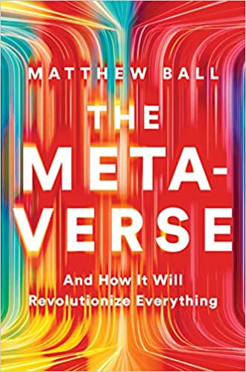

The term “Metaverse” is suddenly everywhere, from the front pages of national newspapers and the latest fashion trends to the plans of the most powerful companies in history. It is already shaping the policy platforms of the US government, the European Union, and the Chinese Communist Party.
But what, exactly, is the Metaverse? As pioneering theorist and venture capitalist Matthew Ball explains, it is a persistent and interconnected network of 3D virtual worlds that will eventually serve as the gateway to most online experiences, and also underpin much of the physical world. For decades, these ideas have been limited to science fiction and video games, but they are now poised to revolutionize every industry and function, from finance and healthcare to education, consumer products, city planning, dating, and well beyond.
Taking us on an expansive tour of the “next internet,” Ball demonstrates that many proto-Metaverses are already here, such as Fortnite, Minecraft, and Roblox. Yet these offer only a glimpse of what is to come. Ball presents a comprehensive definition of the Metaverse before explaining the technologies that will power it―and the breakthroughs that will be necessary to fully realize it. He addresses the governance challenges the Metaverse entails; investigates the role of Web3, blockchains, and NFTs; and predicts Metaverse winners and losers. Most importantly, he examines many of the Metaverse’s almost unlimited applications.
The internet will no longer be at arm’s length; instead, it will surround us, with much of our lives, labor, and leisure taking place inside the Metaverse. Bringing clarity and authority to a frequently misunderstood concept, Ball foresees trillions of dollars in new value―and the radical reshaping of society.

metavèrso s. m. – Termine coniato da Neal Stephenson nel romanzo cyberpunk Snow crash (1992) per indicare uno spazio tridimensionale all'interno del quale persone fisiche possono muoversi, condividere e interagire attraverso personalizzati. (TRECCANI)

The term was coined by Neal Stephenson in his cyberpunk novel Snow Crash (1992), imagining a tridimensional space where people could move, share experiences and actions through avatars.

The metaverse is a virtual world where humans, as avatars, interact with each other in a three-dimensional space that mimics reality. The metaverse is online, but it's also three-dimensional and changeable. The Metaverse is the spatialized Net of the future.

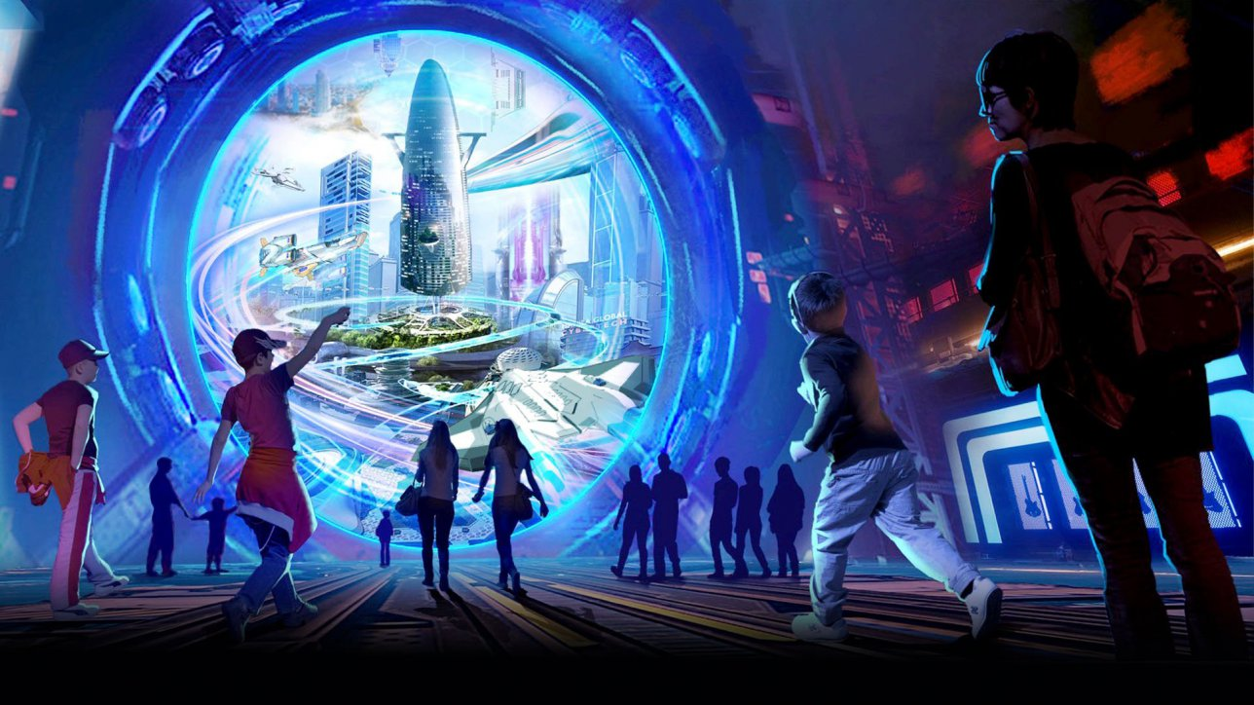

Metaverse Explained: What is the Metaverse, and Why Does it Matter?
One of the major buzzwords this past year has been “metaverse,” triggered in no small part by Facebook’s announcement this past October that it was rebranding to Meta and investing at least $10 billion on metaverse technologies. While the term “metaverse” originated in the 1992 novel Snow Crash, in which people use the metaverse as an escape from a dystopian world (an idea also later explored in the novel and film Ready Player One), only recently has technology improved to the point where the metaverse could leave the realm of science fiction and become a reality. This article will explore what the metaverse is now, and what it may become, as well as some of the companies involved in creating it and opportunities for financial institutions, in particular, to get involved and help shape the future of the metaverse.

What is the Metaverse?

The metaverse has been described in several different ways. The Oxford dictionary defines the word as “a virtual-reality space in which users can interact with a computer-generated environment and other users.” Meta has referred to the metaverse as “a persistent, synchronous environment where we can be together.” The video chat platform startup Gather has shared their definition of the metaverse as “the next iteration of the Internet that brings a sense of place and facilitates rich human connection.”
As the world is likely still several years away from seeing a fully-realized metaverse, it is unclear how exactly the metaverse will look in the end. However, there are a number of facets of the metaverse that most people would agree are core components of the definition of the metaverse.
- The metaverse will be an ecosystem of shared virtual worlds.
While virtual worlds already exist today (for example, within online video games), most worlds are not linked, and consumers cannot move freely in between different worlds in the same way that one could move from one website to another. Assets purchased in one game typically cannot be used or sold in a different game. In the metaverse, it is expected that items such as digital clothing or accessories will be able to be shared across different worlds and experiences. The boom of technologies such as non-fungible tokens (NFTs) may assist in allowing users to use items across different worlds. Further, virtual worlds in the metaverse should be persistent, which is to say that the world will remain regardless of whether users are logged on or logged off, unlike Zoom meetings or video calls which end as soon as the participants leave the room. Changes to these shared worlds could also persist into the future, creating a more realistic and lived-in experience for users.

2. The metaverse will fuse the real world with the digital world.
Creators will be able to recreate real-world spaces or objects in a virtual medium, where users can feel like they are present in the space, as opposed to merely seeing the space via a web browser. Virtual objects may also be embedded into the real world via AR technology. The best current example of this technology is the hit game Pokémon Go. Corporations such as Nike and Gucci are already investing in technology to bring their products and branding into the digital world in the form of skins and digital clothing. In the same way that consumers purchase branded goods and accessories as a form of self-expression in the real world, these digital collectibles will allow users to display their interests and personality in the virtual world. As AR and VR technology improves, companies and creators will find new ways to merge the physical and the digital to create experiences that feel more real and more integrated with the daily life of the average consumer.

3. The metaverse will provide new ways for people to connect and interact with each other in a virtual space.
While the origins of the metaverse may be found in gaming (key examples include Fortnite and Roblox), many in the industry see the opportunity for the metaverse to redefine how and where people connect to each other. The pandemic has shown the vital importance of finding ways for people to meet and engage with others via a virtual medium. In the future, the metaverse may provide channels for people to meet, talk, and enjoy activities and events together, even if they are far apart in the real world. Though the pandemic will hopefully come to an end soon, it is clear that many companies already see a future in remote work that allows the company to save money, while at the same time offering employees a way to avoid the hassle of a regular commute. Families separated across countries or continents will continue to see the metaverse as a way to stay connected in person, even as travel opens back up. By eliminating the physical barriers and limitations of the real world, virtual spaces can democratize access to events, education, and even work opportunities.
Though the metaverse is still in its infancy, many companies have already begun creating and hosting virtual experiences that exemplify how people may interact with the metaverse in the future. Examples include Marshmello’s 2019 concert inside Fortnite (attended virtually by 10.7 million people), or the SXSW Online XR experience in 2021 (which recreated downtown Austin, TX, the traditional host of the SXSW film festival). Companies like BMW and Audi have created virtual showrooms for consumers to shop for and virtually test drive cars, and platforms such as Decentraland and Gather allow users (retail and corporate alike) to create their own spaces for anything from art shows to weekly team game nights.

