View all

The Carnival of Venice (Italian: Carnevale di Venezia) is an annual festival held in Venice, Italy. The carnival ends on Shrove Tuesday (Martedì Grasso or Mardi Gras), which is the day before the start of Lent on Ash Wednesday. The festival is world-famous for its elaborate masks.

Spanish Festivals
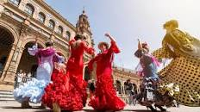

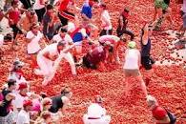

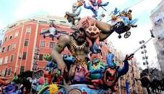

View all

Just scroll down this list of Spanish festivals and get ready to go crazy:
- La Tamborrada (Drum Festival) ...
- Las Fallas De Valencia (Festival Of Fire) ...
- Semana Santa (Holy Week) ...
- Feria Del Caballo (Horse Fair) ...
- Feria De Abril (April Fair Of Seville) ...
- Cordoba Patios Festival. ...
- Benicassim Festival. ...
San Fermin (Pamplona Bull Run)

Indian festivals
India is a land of festivals, where people from different religions coexist harmoniously. The wide variety of festivals celebrated in India is a true manifestation of its rich culture and traditions. There are many Indian festivals and celebrations, the most exciting of which are mentioned below.While the celebrations happen all over the year, October till January is the time when the country can be seen at its vibrant best.
India is one country where every religion and community celebrates their culture. There are festivals of India state wise, religion-based, and community-wise. So, every day is a new celebration in this country. You also enjoy lots of Gazetted holidays that gives you an opportunity to plan a trip across the country.
To give you a fair idea about all the festivals of India in 2021 and their dates, before you begin, here is a piece of information that would prove essential for you! It will also tell you about the importance of the famous festivals of India!

Indian Festivals Calendar 2021
Here is a list of religious and national festivals of India that is celebrated in the country with much gusto and fervor. Plan your holidays around these festivals if you wish to explore the vibrant culture of India.
Month | Festival | Date (2021) | Day
January | Makar Sakranti | 14th January | Thursday
January | Pongal | Begins on 17th January | Sunday
January | Basant Panchami | 16th February | Tuesday
February | Maha Shivratri | 11th March | Thursday
March | Holi | 29th March | Monday
March | Mewar | Begins from 27th March | Friday
April | Baisakhi | 14th April | Wednesday
April | Bihu | Begins on 13th April | Tuesday
May | Thrissur Pooram | 3rd May | Sunday
May | Buddha Jayanti | 7th May | Thursday
May | Eid Ul Fitr | 13th May | Thursday
June | Ratha Yatra | 23rd June | Tuesday
June | Hemis | 30th June | Wednesday
August | Rakshabandhan | 22nd August | Sunday
August | Janmashtmi | 12th August | Wednesday
August | Independence Day | 30th August | Monday
August | Onam | Begins on 23rd August | Monday
August | Ganesh Chaturthi | 10th September | Friday
October | Navratri | From 7th to 14th October | Thursday
October | Durga Puja | 15th October | Friday
October | Dussehra | 30th October | Friday
November | Diwali | 4th November | Thursday
November | Gurupurab | 19th November | Friday
December | Christmas | 25th December | Saturday

13. Onam: Welcoming The Mighty Mahabali (Begins on 23rd August, Monday)
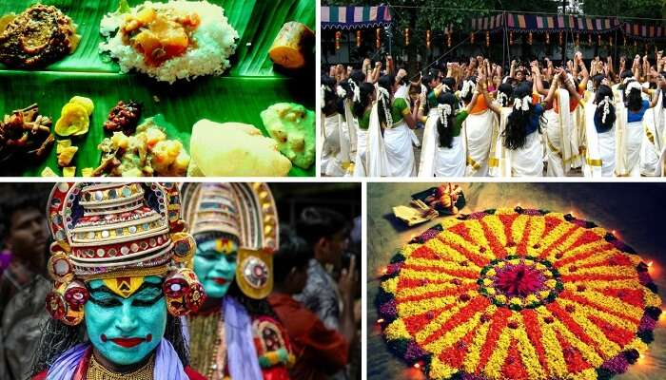
<img class="alignnone size-full wp-image-16529" src="https://img.traveltriangle.com/blog/wp-content/uploads/2015/11/onam.jpg" alt="Onam is one of the important festivals of India" width="700" height="400" />
Onam is among the important national festivals of India, wherein people wear traditional wear, adorn houses with Pookalam (floral designs), and prepare Onasadya (elaborate meal of about 13 dishes). Events such as Vallamkali (snake boat race), Kaikottikali (clap dance), Kathakali dance, and Pulikali procession (artists dressed and painted like tigers and hunters) are held.
Significance: It celebrates the homecoming of the legendary king Mahabali.
Key attractions: The spectacular Snake Boat Race, the enigmatic Kaikottikali dance, and the Elephant procession
When: In the month of Chingam of the Malayalam calendar, which corresponds to August or September of the Gregorian calendar
Where: Celebrated by people of all communities in the state of Kerala.
Onam 2021: Begins on 23rd August (Monday)
Things To Do: Attend boat races, and other ceremonies
Suggested Read: 10 Uncommon & Unusual Festivals In India

